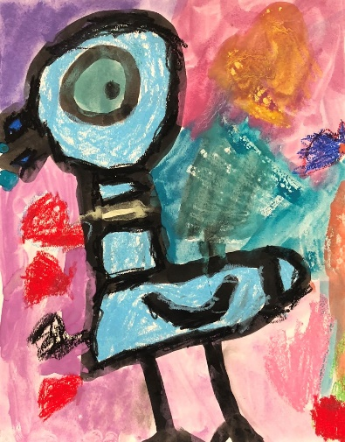
Free Online Resources for
Arts and Education

Issaquah Schools Foundation - http://isfdn.org/parents/ A great resource for parents with fun and active games and websites to help keep students engaged in learning a variety of topics.
Docent Facebook page - https://www.facebook.com/IssaquahPTSAArtDocents/ Art resources and information.

Art Lessons
Artistic Support lessons - http://isfdn.org/art-docent-lessons-by-grade/ Art lessons by grade, medium, or subject.
Art for Kids Hub - https://www.youtube.com/user/ArtforKidsHub Elementary art lessons.
Arts Ed Washington - https://artsed-washington.github.io/alic/ Art lessons aligned to Washington state standards.
Arts Impact - https://arts-impact.org/lessons/ Culturally cognizant, art lessons which are integrated into other subjects.
Deepaksart - www.facebook.com/deepaksart/ Art videos and instruction.
Deep Space Sparkle - https://www.deepspacesparkle.com/ Beautiful art lessons and videos.
Eyeball It Art 4 Kids - http://www.eyeballitart4kids.org/ Art lessons and videos.
Happiness is Homemade - https://www.happinessishomemade.net/36-elementary-art-lessons-for-kids/ Weekly art lessons and nicely organized by grade or topic.
Incredible Art - https://www.incredibleart.org/ Art lessons and parent and instructor resources.
Spark - https://spark.adobe.com/page/ANOTGsW0Th5UQ/Dance videos and instruction ideas.
Teach Kids Art - https://www.teachkidsart.net/ Lots of projects with common household materials.
Virtual Instructor - https://www.youtube.com/watch?v=Q6bu6SIraJk Art lessons, for a short time, for older students lessons, usually by membership only.
Movies & videos
Kanopy for Kids* - https://www.kanopy.com/ Movies and documentaries. *Free with King County Library card.
People - https://people.com/travel/stuck-at-home-these-12-famous-museums-offer-virtual-tours-you-can-take-on-your-couch/ 12 Famous Museums Offer Virtual Tours

Teacher Resources
Education Closet - https://educationcloset.com/ Online courses, resources and curriculum for teaching arts integration.
Guggenheim Museum - https://archive.org/details/guggenheimmuseum Art Books to view.
Kennedy Center - https://www.kennedy-center.org/education/resources-for-educators/classroom-resources/Resources for teaching and planning art lessons.
Online Arts and Design Instruction - https://www.facebook.com/groups/onlineartanddesigninstruction/about/ Discussion about moving online as an arts educator.

