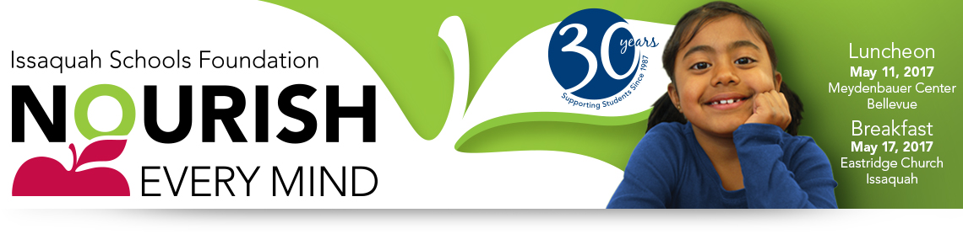
FACT SHEET

What: The Issaquah Schools Foundation’s Nourish Every Mind fundraising events.
19th Annual Luncheon & 4th Annual Breakfast

When: Luncheon • Thursday, May 11, 2017 • Meydenbauer Center, Bellevue • 12:00 pm – 1:00 pm
Doors open at 11:00 am with a wine wall, program displays, time for networking & more.

Breakfast • Wednesday, May 17, 2017 • Eastridge Church, Issaquah • 7:30 am – 8:30 am
Doors open at 7:00 am with program displays, time for networking and a breakfast buffet.

Donation: $150 minimum suggested donation. Only $12.50/month!

Why: To help all students achieve the promise of their potential. Donors contributed more than $1.8 million last year to support students when they struggle, when they excel and all times in between. From leading-edge STEM curriculum to financial literacy, arts programs and after-school tutoring, the funds you donate to the Foundation ensure that kids of all abilities have the support they need to navigate their own unique path to success.
• Washington state ranks 43rd of 50 states in education funding
• Issaquah is 295th of 295 WA districts in per pupil funding from the state
• Community investment provides schools and teachers the opportunity to put
funding to use where it will help students in effective and innovative ways
The Events: The Nourish Every Mind Luncheon and Breakfast will attract more than 1,200 civic and business leaders, parents, and educators for events that showcases Issaquah Schools Foundation grant recipients, celebrates the partnership between the Issaquah School District and the Foundation, and informs guests of the continued and growing need for private support of public education.

Food offered at the events this year. Both lunches are gluten free.
- Regular lunch - Seattle Cider Chicken: Red potatoes, stone-ground mustard, green beans, golden roasted beets, sweet potato angel hair, shaved manchego cheese.
- Vegetarian option - Tuscan white bean and kale salad: Quinoa, feta cheese, Kalamata olives, garbanzo beans, roasted red peppers, red onion citrus vinaigrette.
- Breakfast - Buffet
Auction: The auction is available online only from April 28 – May 8, 2017 at http://isfdn.org/auction
Each year, community members bid on an array of items, including gourmet dinners, wine tastings, local services for car, home and more. The auction is open to everyone.

More Info: Event Chair — Carolyn Kennedy, carolynk2@hotmail.com
Table Captain Chair — Lisa Small, lisaogami@hotmail.com
Sponsorships – Val Korock, valerie@isfdn.org

Our generous sponsors underwrite the events, so 100% of contributions directly support our students.

Issaquah Schools Foundation • PO Box 835 Issaquah WA 98027 • www.isfdn.org • 425.391.8557

