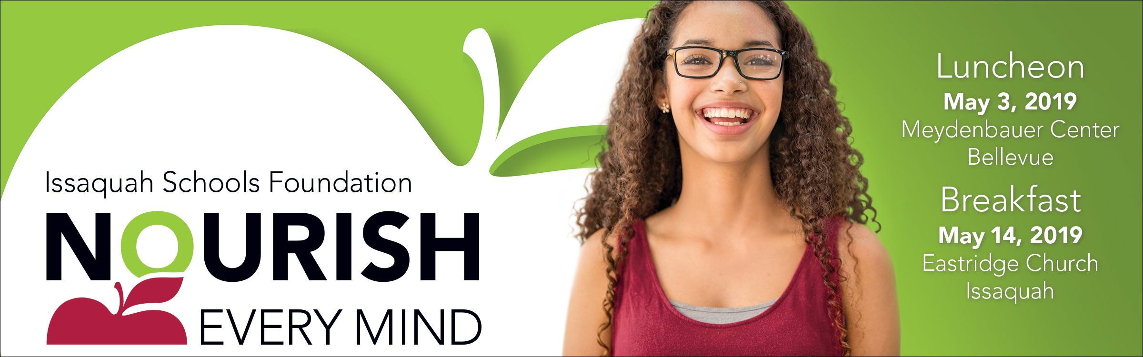

FACT SHEET

What: The Issaquah Schools Foundation’s Nourish Every Mind fundraising events.
21st Annual Luncheon and 6th Annual Breakfast

When: Luncheon • Friday, May 3, 2019 • Meydenbauer Center, Bellevue
12:00 pm – 1:00 pm. Doors open at 11:00 am with a wine wall, program displays & time for networking

Breakfast • Tuesday, May 14, 2019 • Eastridge Church, Issaquah
7:30 am – 8:30 am. Doors open at 7:00 am with time for networking and a breakfast buffet.

Donation: $150 minimum requested donation. Only $12.50/month!

Why: To help all students achieve the promise of their potential. Donors to the Foundation support students when they struggle, when they excel, and all times in between. From leading-edge STEM curriculum and arts programs to after-school tutoring and food for students in need, the funds you donate to the Foundation ensure that kids of all abilities have the support they need to navigate their own unique path to success.

The Events: The Nourish Every Mind Luncheon and Breakfast events will showcase Issaquah Schools Foundation funded programs and grant recipients, celebrate the partnership between the Issaquah School District and the Foundation, and inform guests of the continued need for private support of public education.

Auction: The auction is available online only from April 19 – April 29, 2019 at http://isfdn.org/auction. The auction is open to everyone and includes a wide variety of items including restaurant gift cards, wine tastings, unique get-a-ways, and one of a kind school experiences.

More Info: Event Lead — Carolyn Kennedy, c.kennedy@isfdn.org
Table Captain Lead — Trisha Marshall, tsm0507@gmail.com
Sponsorships – Val Korock, valerie@isfdn.org

Our generous sponsors underwrite the events
100% of contributions directly support our students.

Issaquah Schools Foundation • www.isfdn.org • 425.391.8557

