The Issaquah Schools Foundation funds programs that support students in building academic foundations, exploring limitless opportunities, and launching successfully into the future.

Academic Support
After School Assistance Program (ASAP) - Certified staff on hand to help students reach grade level in math, reading, or writing at the elementary level.

After School Homework - Homework Labs at high schools and open libraries at middle schools give every student access to free academic support and/or a supervised location to study or use a computer after school.

Highly Capable – Support for materials and teacher training programs essential to challenging this unique group of students.

Impact Scholarships – Scholarships awarded annually to help juniors and seniors in the Issaquah School District.
New Teacher Funds - Welcome packet for new teachers to the district. A gift card and local business coupons for materials to help them set up their classrooms.

Teacher Grants - (Kateri Brow and Classroom Enrichment) Grants provide teachers with funding for projects that enrich education, fill unmet needs, and serve as incubators for innovation throughout the district.

Basic Needs

Food Support - Provides breakfasts, snacks and lunches throughout the ISD. Nutritious meals and learning go together, and students who eat breakfast and lunch are better able to focus on their studies.

Nurses Fund Support - This special fund allows Issaquah School District nurses to assist students and families struggling to pay for necessities.

Student Intervention Services - Provides professional development opportunities for student support coach’s and counselors as well as helping with the purchase of curriculum kits as needed.

Testing Scholarships – Scholarships offered for 10th and 11th grade students who need support, ensuring they can take critical pre-college AP and IB exams to test their knowledge of rigorous coursework and earn college credit.

Tools4School - A partnership between the Issaquah Schools Foundation and Issaquah Food & Clothing bank to provide new backpacks filled with school supplies for Issaquah School District K-12 students who need support.

The Arts

Artistic Support - Provides free art instruction and lesson plans for volunteer art docents in each elementary school which align with our states visual arts learning standards.

Dedicated Fine Arts Fund - Supports drama, visual arts, vocal music, band, and orchestra in district secondary schools.

Professional Development & Career

Career & Technical Education (CTE) Teacher Support - Provide support for teachers to receive additional training and certification in areas that provide students with real world application including: Sports Medicine, Video Production, Business and Marketing, Theater Production, Culinary Arts and Forensic Science.
Great Careers Conference - Held in partnership with the Issaquah Chamber of Commerce, the Great Careers Conference introduces students to secondary education options outside a four-year college.

STEM

After School Robotics – Funding provided for materials needed for school robotics clubs that often compete in local and regional competitions, with the possibility of advancing to the world competition.

Elementary Computational Thinking (Computer Science) - Prepares teachers to integrate computational thinking and computer science pedagogy throughout their teaching.

Science Tech Magnet Program Support - Supports the ISD's Science Tech Magnet program for 4th and 5th grade students

STEM Clubs - STEM funding to each high school to further enrich cocurricular and extra-curricular clubs and classes that provide valuable learning opportunities for students in STEM related fields. Clubs/classes include: Rocketry, Environmental Science, Video Production, Forensics and Engineering.

Family Engagement

Cultural Bridges - A Foundation run program that helps build relationships between families from diverse cultures and languages, the ISD, and the broader Issaquah community through outreach, events, mentoring, translation services and a magazine printed in 6 languages.

ParentWiser Education Support – ParentWiser is a parent education speaker series of Issaquah PTSA Council comprised of local and nationally-known experts who are invited to share the latest information in effective parenting with parents of the Issaquah School District.

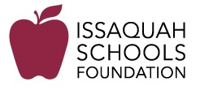

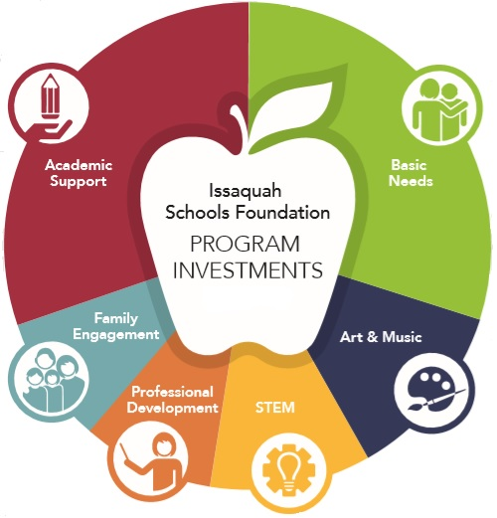

2019-2020
Program Guide

