Sample Email to New Guest

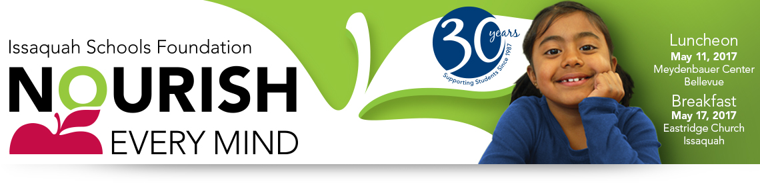

Hello,

Please join me in celebrating the Issaquah Schools Foundation’s 30th year anniversary! The Nourish Every Mind Benefit events are going to be a big celebration and wonderful fundraisers. To help celebrate this milestone and accommodate our growing community, the luncheon this year will be held at Meydenbauer Center in Bellevue on May 11th 2017. The breakfast will be at Eastridge Church in Issaquah on May 17, 2017.

I’m hosting a table at [list either and/or both events as applicable] and would be honored if you would join me. Although I will not be a Table Captain at [list which event], I am happy to help sign you up for that event and the Table Captain Team will make sure you are well taken care of.

These events are a great way to learn more about the Issaquah Schools Foundation, socialize, and hear firsthand from students and staff who have directly benefited from Foundation investments. You’ll also discover why private support is the quickest path to improvement of our public schools.

The suggested minimum donation at the Luncheon and Breakfast is $150 (only $12.50/month!), all used to support programs and initiatives that touch the lives of all Issaquah School District students.

I hope you can join me for this inspirational and informative event. I’ll call to follow up soon.

19th Annual Nourish Every Mind Benefit Luncheon
Thursday, May 11, 2017, Meydenbauer Center, Bellevue
11:00 am – Networking time, wine wall, displays and more
Noon – 1:00 pm - Lunch & Program

4th Annual Nourish Every Mind Benefit Breakfast
Wednesday, May 17, 2017 at Eastridge Church, Issaquah
7:00 – 7:30 am – Networking time, displays and Breakfast Buffet
7:30 – 8:30 am - Program

If you’re unable to attend you can still support our students and schools.
Participate in the Online Auction from April 28 – May 8, 2017 at http://isfdn.org/auction.

Sample Email to Returning Guest

Hello,

It’s that time again! I hope you’ll join me to help me celebrate the Issaquah Schools Foundation 30th year anniversary! The Nourish Every Mind Benefit events are going to be a big celebration and wonderful fundraisers. To help celebrate this milestone and accommodate our growing community, the luncheon this year will be held at Meydenbauer Center in Bellevue on May 11th 2017. The breakfast will be at Eastridge Church in Issaquah on May 17, 2017.

As you know, it’s a great way to reconnect with the Foundation, socialize and hear success stories from students and staff who have benefitted from your generosity. I will be a Table Captain at the [list which event], but if the [list other event] works better for you, I am happy to help sign you up for that event and the Table Captain Team will make sure you are well taken care of.

These events are a great way to learn more about the Issaquah Schools Foundation, socialize, and hear firsthand from students and staff who have directly benefited from Foundation investments.

The suggested minimum donation at the Luncheon and Breakfast is $150 (only $12.50/month!), all used to support programs and initiatives that touch the lives of all Issaquah School District students.

I look forward to sharing this inspirational event with you. Please call or email with your response as soon as you can. I’m saving a seat for you!

19th Annual Nourish Every Mind Benefit Luncheon
Thursday, May 11, 2017, Meydenbauer Center, Bellevue
11:00 am – Networking time, wine wall, displays and more
Noon – 1:00 pm - Lunch & Program

4th Annual Nourish Every Mind Benefit Breakfast
Wednesday, May 17, 2017 at Eastridge Church, Issaquah
7:00 – 7:30 am – Networking time, displays and Breakfast Buffet
7:30 – 8:30 am - Program

If you’re unable to attend you can still support our students and schools.
Participate in the Online Auction from April 28 – May 8, 2017 at http://isfdn.org/auction.

