Sample Email to New Guest

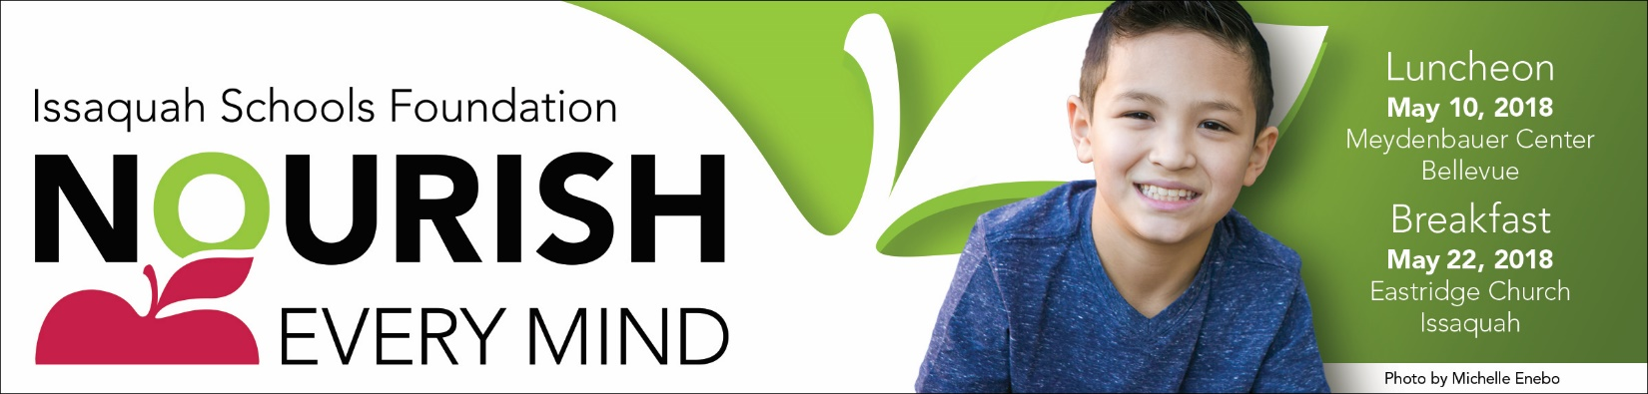

Hello,

Do you ever wonder what it takes for kids to learn – a well-nourished child, a rich learning environment, a well-prepared educated teacher, a supportive family? Each of these elements contribute to the success of student learning.

Please join me to learn how our community can support the needs of students at the Issaquah Schools Foundation’s Nourish Every Mind Luncheon, to be held at Meydenbauer Center May 10, 2018 or breakfast held at Eastridge Church in Issaquah on May 22, 2018.

I’m hosting a table at [list either and/or both events as applicable] and would be honored to have you join me. Although I will not be a table captain at [list which event], I am happy to help sign you up for that event and we will make sure you are well taken care of.

Nourish Every Mind is a great way to learn more about the Issaquah Schools Foundation and hear first-hand from students and staff who have directly benefited from Foundation investments. You’ll also discover why private support is the quickest path to improvement of our public schools.

The requested minimum donation at the luncheon and breakfast is $150, or $12.50/month, all used to support programs and initiatives that touch the lives of all Issaquah School District students.

I hope you will join me for this inspirational and informative event. I’ll call to follow up soon.

20th Annual Nourish Every Mind Benefit Luncheon
Thursday, May 10, 2018, Meydenbauer Center, Bellevue
11:00 am – Networking time, wine wall, displays and more
Noon – 1:00 pm - Lunch & Program

5th Annual Nourish Every Mind Benefit Breakfast
Tuesday, May 22, 2018 at Eastridge Church, Issaquah
7:00 – 7:30 am – Networking time and breakfast buffet
7:30 – 8:30 am - Program

If you’re unable to attend, you can still support our students and schools.
Participate in the Online Auction from April 27 – May 7, 2018 at http://isfdn.org/auction.

Sample Email to Returning Guest

Hello,

Do you ever wonder what it takes for kids to learn – a well-nourished child, a rich learning environment, a well-prepared educated teacher, a supportive family? Each of these elements contribute to the success of student learning.

Please join me to learn how our community can support the needs of students at the Issaquah Schools Foundation’s Nourish Every Mind Luncheon, to be held at Meydenbauer Center May 10, 2018 or breakfast held at Eastridge Church in Issaquah on May 22, 2018.

As you know, it’s a great way to reconnect with the Foundation, socialize and hear success stories from students and staff who have benefitted from your generosity. I am a table captain at the [list which event], but if the [list other event] works better for you, I am happy to help sign you up for that event and we will make sure you are well taken care of.

These events are a great way to learn more about the Issaquah Schools Foundation, socialize, and hear firsthand from students and staff who have directly benefited from Foundation investments.

The requested minimum donation at the Luncheon and Breakfast is $150, or $12.50/month, all used to support programs and initiatives that touch the lives of all Issaquah School District students.

I look forward to sharing this inspirational event with you. Please call or e-mail (place to insert phone number/e-mail address?) with your response as soon as you can. I’m saving a seat for you!

20th Annual Nourish Every Mind Benefit Luncheon
Thursday, May 10, 2018, Meydenbauer Center, Bellevue
11:00 am – Networking time, wine wall, displays and more
Noon – 1:00 pm - Lunch & Program

5th Annual Nourish Every Mind Benefit Breakfast
Tuesday, May 22, 2018 at Eastridge Church, Issaquah
7:00 – 7:30 am – Networking time and breakfast buffet
7:30 – 8:30 am - Program

If you’re unable to attend, you can still support our students and schools.
Participate in the Online Auction from April 27 – May 7, 2018 at http://isfdn.org/auction.

