Sample guest email

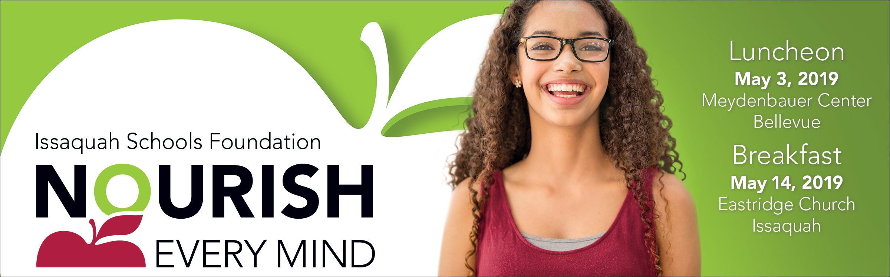

Hello,

Please join me to learn how our community can ensure that students of all abilities have the support they need to navigate their own unique path to success.

I’m hosting a table at the Issaquah Schools Foundation’s [luncheon event and/or breakfast event - list either and/or both events as applicable] and would be honored to have you join me. Although I will not be a table captain at the [Luncheon/Breakfast], I am happy to help sign you up for that event and we will make sure you are well taken care of.

Nourish Every Mind is a great way to learn more about the Issaquah Schools Foundation and hear first-hand from students and staff who have directly benefited from Foundation investments.

The requested minimum donation at these events is $150, or $12.50/month, all used to support programs and initiatives that support all Issaquah School District students. Donations at all levels are greatly appreciated.

I hope you will join me for this inspirational and informative event. I’ll [call/email] to follow up soon.

21st Annual Nourish Every Mind Benefit Luncheon
Friday, May 3, 2019, Meydenbauer Center, Bellevue
11:00 am – Networking time, wine wall, and displays
Noon – 1:00 pm - Lunch & Program

6th Annual Nourish Every Mind Benefit Breakfast
Tuesday, May 14, 2019 at Eastridge Church, Issaquah
7:00 – 7:30 am – Networking time and breakfast buffet
7:30 – 8:30 am - Program

*Note: If you’re unable to attend, you can still support our students.
- Participate in the Online Auction from April 19 – April 29, 2019 at http://isfdn.org/auction.
- Direct donations may also be made online at http://isfdn.org
Thank you!

