Sign-up sheet

Luncheon • Thursday, May 10, 2018 • Meydenbauer Center, Bellevue • 12:00 pm – 1:00 pm
Doors open at 11:00 am with a wine wall, program display, time for networking & more.

Breakfast • Tuesday, May 22, 2018 • Eastridge Church, Issaquah • 7:30 am – 8:30 am
Doors open at 7:00 am with time for networking and a breakfast buffet.
$150 minimum requested donation. Only $12.50/month!
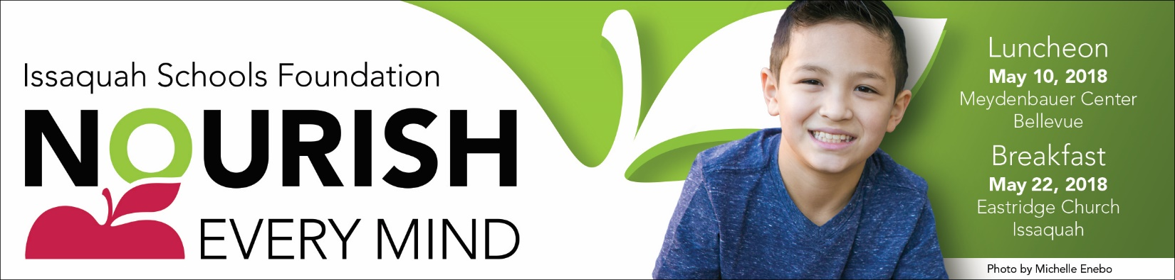
Regular Vegetarian
Name Lunch Lunch Breakfast
1
2
3
4
5
6
7
8
9
10
If you cannot attend either event, you can still support the Foundation by donating at http://isfdn.org, or participating in the online auction! The auction will be available to everyone online only April 27th – May 7th 2018 http://isfdn.org/auction
- Regular lunch – Asian Chicken on GF noodles: Gochujang Marinated Chicken Breast, glass noddle’s, garbanzo miso dressing, fresh sugar snap peas, bean sprouts, shredded carrot, red peppers, cucumber and celery tossed in a sesame ginger vinaigrette. (Dairy Free, Gluten Free)
- Vegetarian option - Tuscan white bean and kale salad: Quinoa, feta cheese, Kalamata olives, garbanzo beans, roasted red peppers, red onion citrus vinaigrette. (Gluten Free)
- Breakfast - Buffet
Contact Information
Table Captain Lead: Trisha Marshall tsm0507@gmail.com
Nourish Every Mind Event Lead: Carolyn Kennedy c.kennedy@isfdn.org
Our generous sponsors underwrite the events, so 100% of contributions directly support our students.

Issaquah Schools Foundation • PO Box 835 Issaquah WA 98027 • www.isfdn.org • 425.391.8557

