The Issaquah Schools Foundation funds programs that support students in building academic foundations, exploring limitless opportunities, and launching successfully into the future.

Academic Support
After School Assistance Program – All Title 1 Elementary Schools. This program provides funding for certified staff to help students in math, reading, or writing at the elementary level.

After School Homework – All Middle & High Schools.
Homework Labs at high schools and open libraries at middle schools give students access to free academic support and/or a supervised location to study or use a computer after school.

Highly Capable – Elementary program.
This funding provides support for materials and teacher training programs essential to challenging this unique group of students.

Impact Scholarships – Available to all HS Juniors & Seniors.
The Foundation awards college scholarships annually to help juniors and seniors in the Issaquah School District.
New Teacher Funds – All new teachers. This is a welcome packet for all new teachers to the district. A gift card from the Foundation and local business coupons provide support for materials to help them set up their classrooms.

Teacher Grants – Available to all teachers. The Foundation provides an opportunity for all teachers to apply for grants to fund projects that enrich education, fill unmet needs, and/or serve as incubators for innovation.

Basic Needs

Food Support – All Schools. This program provides funding for breakfast food, snacks, and lunches throughout the district. Nutritious food helps students focus on their studies.

Nurses Fund Support – All Schools. This fund allows district nurses the opportunity to assist students and families struggling to pay for necessities.

Student Intervention Services – All Schools. This funding provides professional development opportunities for student support coach’s and counselors as well as funding for curriculum, kits, or materials as needed.

Testing Scholarships – All High Schools. Scholarships offered for 10th and 11th grade students who need support, ensuring they can take pre-college AP and IB exams to earn college credit.

Tools4School – All schools. A partnership between the Issaquah Schools Foundation and Issaquah Food & Clothing bank to provide new backpacks filled with school supplies for Issaquah School District K-12 students who need support.

The Arts

Artistic Support – All Elementary schools. In partnership with the PTSAs, this program provides free art instruction and lesson plans for volunteer art docents in each elementary school.

Dedicated Fine Arts Fund – All Middle & High Schools. This program supports funding for drama, visual arts, vocal music, band, and orchestra in district secondary schools.

Professional Development & Career

Career & Technical Education (CTE) Teacher Support – Available to all teachers. Support for teachers to receive training and certification in areas that provide students with real world application including: Sports Medicine, Video Production, Business & Marketing, Theater Production, Culinary Arts and Forensic Science.

Great Careers Conference – Available to High School Students. Held in partnership with the Issaquah Chamber of Commerce, the Great Careers Conference introduces students to secondary education options outside a four-year college.

STEM

Robotics – All Schools. Funding provided for materials needed for school robotics clubs that often compete in local and regional competitions at the middle and high school level. Funding for participation in the FIRST Lego League robotics program at the elementary level.

Science Tech Magnet Program Support – Elementary Program. Supports the district's Science Tech Magnet program for 4th and 5th grade students

STEM Clubs – All High Schools. Science Technology Engineering & Math funding to each high school to further enrich clubs and classes that provide opportunities for students in STEM related fields. Clubs/classes include: Rocketry, Environmental Science, Video Production, Forensics and Engineering.

Family Engagement

Cultural Bridges – All Schools. A Foundation run program that helps build relationships between families from diverse cultures and languages, the ISD, and the broader Issaquah community through outreach, events, mentoring, translation services, and a magazine printed in 6 languages.

ParentWiser Education Support – Available to all parents in the district. Foundation funding helps to support this parent education speaker series of Issaquah PTSA Council. The series is comprised of local and nationally-known experts who are invited to share the latest information in effective parenting with parents of the Issaquah School District.
Document updated 10/2/2019
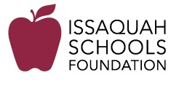

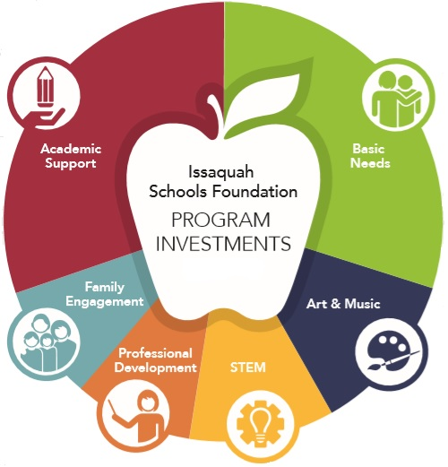

2019-2020
Program Guide

Issaquah Schools Foundation
www.isfdn.org | 425.391.8557
info@isfdn.org

